
Perth Modern School
End of Year Examination, 2012

Question/Answer Booklet

MATHEMATICS 3C/3D
SOLUTIONS

Section Two:

Calculator-assumed

Student Number: In figures

In words

Your name

Time allowed for this section
Reading time before commencing work: ten minutes
Working time for this section: one hundred minutes

Materials required/recommended for this section

To be provided by the supervisor
This Question/Answer Booklet
Formula Sheet (retained from Section One)

To be provided by the candidate
Standard items: pens, pencils, pencil sharpener, eraser, correction fluid/tape, ruler, highlighters

Special items: drawing instruments, templates, notes on two unfolded sheets of A4 paper, and up to three calculators satisfying the conditions set by the Curriculum Council for this examination.

Important note to candidates

No other items may be used in this section of the examination. It is your responsibility to ensure that you do not have any unauthorised notes or other items of a non-personal nature in the examination room. If you have any unauthorised material with you, hand it to the supervisor before reading any further.

Structure of this paper

Section | Number of questions available | Number of questions to be answered | Working time (minutes) | Marks available | Percentage of exam
Section One:  Calculator-free | 7 | 7 | 50 | 50 | 33
Section Two:  Calculator-assumed | 13 | 13 | 100 | 100 | 67
 |  |  | Total | 150 | 100

Instructions to candidates

- The rules for the conduct of Western Australian external examinations are detailed in the Year 12 Information Handbook 2012. Sitting this examination implies that you agree to abide by these rules.

- Write your answers in the spaces provided in this Question/Answer Booklet. Spare pages are included at the end of this booklet. They can be used for planning your responses and/or as additional space if required to continue an answer.
- Planning: If you use the spare pages for planning, indicate this clearly at the top of the page.
- Continuing an answer: If you need to use the space to continue an answer, indicate in the original answer space where the answer is continued, i.e. give the page number. Fill in the number of the question(s) that you are continuing to answer at the top of the page.

- Show all your working clearly. Your working should be in sufficient detail to allow your answers to be checked readily and for marks to be awarded for reasoning. Incorrect answers given without supporting reasoning cannot be allocated any marks. For any question or part question worth more than two marks, valid working or justification is required to receive full marks. If you repeat an answer to any question, ensure that you cancel the answer you do not wish to have marked.

- It is recommended that you do not use pencil, except in diagrams.

Section Two: Calculator-assumed (100 Marks)
This section has thirteen (13) questions. Answer all questions. Write your answers in the spaces provided.

Working time for this section is 100 minutes.

Question 8 (5 marks)
(a) The curve 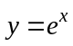 is translated 1 unit in the direction of the positive -axis followed by a dilation in the direction of the positive -axis by a factor of 3. State the exact coordinates of the -intercept of the transformed curve. (2 marks)

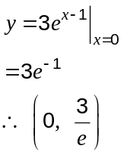

(b) State a sequence of transformations that would transform the graph of 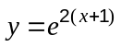 into the graph of 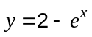. (3 marks)
Translate 1 unit right.

Dilate in the direction of the positive -axis by a factor of 2.

Reflect in the -axis.

Translate 2 units up.

Question 9 (7 marks)
Atmospheric pressure, (kPa), decreases approximately exponentially with increasing height (m), above sea level according to the relationship 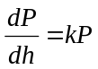 , where is a constant. Atmospheric pressure at sea level is 101.3 kPa, and halves with every 5 800 m increase in height.

(a) Find the value of , rounded to four significant figures. (2 marks)

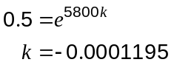

(b) Calculate the atmospheric pressure at the top of a mountain of height 3 785 m.
(2 marks)
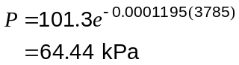

(c) Use the increments formula to find the approximate change in pressure as a climber descends 250 m from the top of a mountain of height 3 785 m. (3 marks)

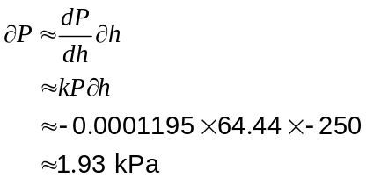

(An increase in pressure)

Question 10 (9 marks)
(a) Even numbers are to be formed using some, or all, of the digits 5, 6, 7, 8 and 9.

(i) How many even numbers can be formed in this way, if repetition of digits is not allowed? (3 marks)

1-digit:
2-digit: 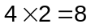
3-digit: 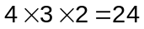
4-digit: 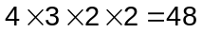
5-digit: 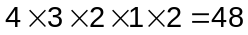

Total = 130 even numbers

(ii) What fraction of the numbers in (i) start with a 9? (2 marks)
2-digit: 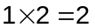
3-digit: 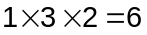
4-digit: 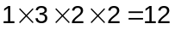
5-digit: 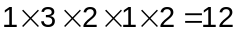

Fraction 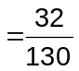

(b) The journey time for a driver between two depots is normally distributed with mean of 55 minutes and standard deviation of 4.5 minutes.

(i) If the driver makes four journeys every day, for five days a week, and for 48 weeks each year, how many of these journeys take less than an hour? (2 marks)

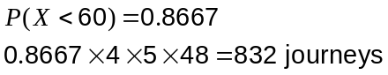

(ii) What is the probability that a journey takes at least an hour, given that it takes less than 65 minutes? (2 marks)

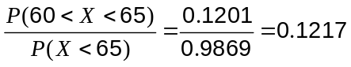

Question 11 (7 marks)
On the basis of the results obtained from a random sample of 81 bags produced by a mill, the 95% confidence interval for the mean weight of flour in a bag is found to be (514.56 g, 520.44 g).

(a) Find the value of , the mean weight of the sample. (1 mark)
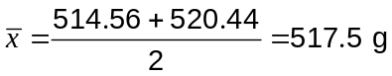

(b) Find the value of , the standard deviation of the normal population from which the sample is drawn. (2 marks)
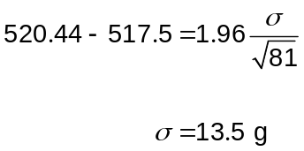

(c) Calculate the 99% confidence interval for the mean weight of flour in a bag. (2 marks)

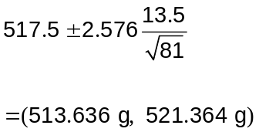

(d) Using the sample mean from (a) as the best estimate for the population mean, what is the probability that the sample mean of a larger sample of 225 bags is less than 516 g?
(2 marks)
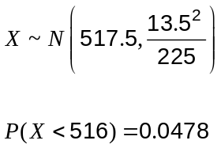

Question 12 (6 marks)
A body is moving in a straight line with velocity, m/s, given by 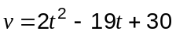, where is the time, in seconds, since the body first passed through a fixed point P.

(a) Show that the body is stationary twice and find the distance travelled by the body between these two instants. (3 marks)

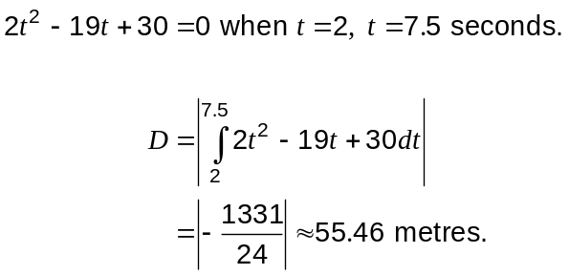

(b) At what other time(s), if any, does the body again pass through the fixed point P?
(3 marks)
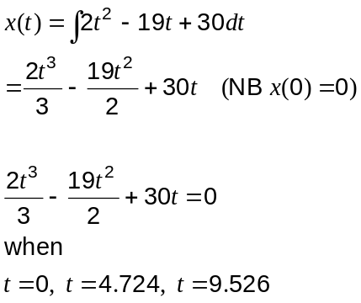

Hence after 4.724 and 9.526 seconds.

Question 13 (12 marks)
(a) A pottery produces souvenir coffee mugs, of which it is known that 5% are defective.

(i) In a box of 24 mugs, what is the probability that there are at least 4 defectives?
(2 marks)

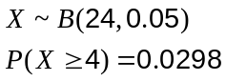

(ii) In a box of 12 mugs, what is the probability that there are no defectives? (1 mark)
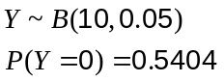

(iii) What is the probability that in 10 boxes, each containing 12 mugs, that either two or three of the boxes contain no defectives? (2 marks)
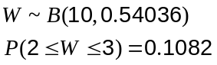

(iv) The pottery decides to pack mugs per box for wholesale clients, so that the chance of there being at least one defective mug in a box is no more than 50%. Find the largest value of . (2 marks)

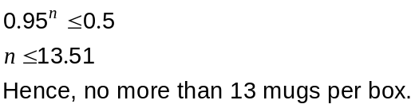

(b) A worker at the pottery took 150 of the defective mugs, filled them with soil and then planted four seeds in each. After 14 days, the number of seeds which germinated in each of the mugs was noted, with these results:

Number of germinating seeds | 0 | 1 | 2 | 3 | 4
Number of mugs | 1 | 9 | 16 | 57 | 67

(i) What is the mean number of seeds germinating per mug? (1 mark)
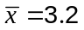

(ii) What is the probability of one seed germinating? (1 mark)
If 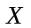 is the random variable 'number of seeds germinating out of four', then assume that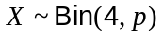. 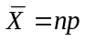 and so 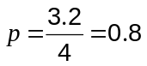

(iii) Use an associated binomial distribution to calculate the theoretical frequency distribution for the number of seeds germinating in the 150 mugs and comment on how well your distribution models the observed results above. (3 marks)
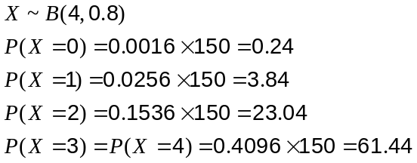

Seeds | 0 | 1 | 2 | 3 | 4
Expected | 0 | 4 | 23 | 62 | 61

The theoretical results are a reasonably close match to the observed results, suggesting that the binomial model is appropriate.
Question 14 (6 marks)
A spherical snowball is melting at a rate of 18 litres per hour.

At the instant the volume of the snowball is 4 000 cm³, calculate

(a) the rate of change of radius of the snowball, in cm per minute. (4 marks)
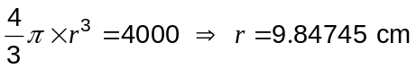

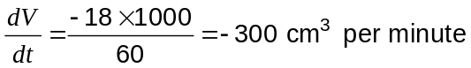

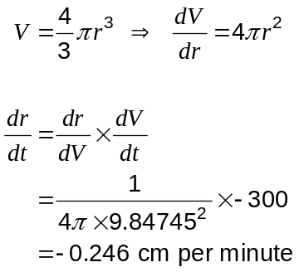

(b) the rate at which the surface area of the snowball is decreasing, in cm² per minute.
(2 marks)
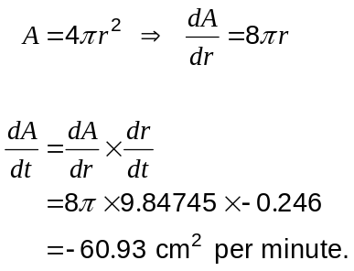

Decreasing at 60.9 cm² per minute.

Question 15 (9 marks)
At the end of a technology course, all students sat a practical and a theory examination, with 20% achieving a distinction in the practical examination, 3% of students achieving distinctions in both examinations and 76% achieving no distinction in either examination.

(a) What is the probability that a student chosen at random from the course achieved a distinction in the theory examination? (4 marks)

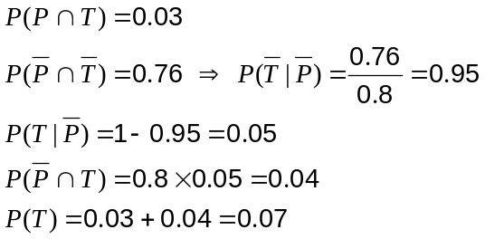

(b) Are the events 'achieving a distinction in the practical examination' and 'achieving a distinction in the theory examination' independent? Explain your answer. (2 marks)

No. From above it can be seen that
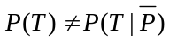.

(c) In a group of 14 students who took the course, three achieved a distinction in the practical examination. If five students are selected at random from this group, what is the probability that at least two of them achieved a distinction in the practical examination? (3 marks)

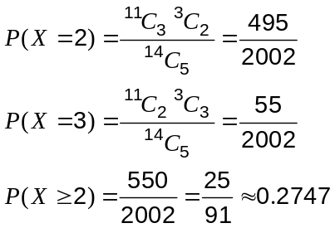

Question 16 (10 marks)
The feasible region of a linear programming problem is shown below.
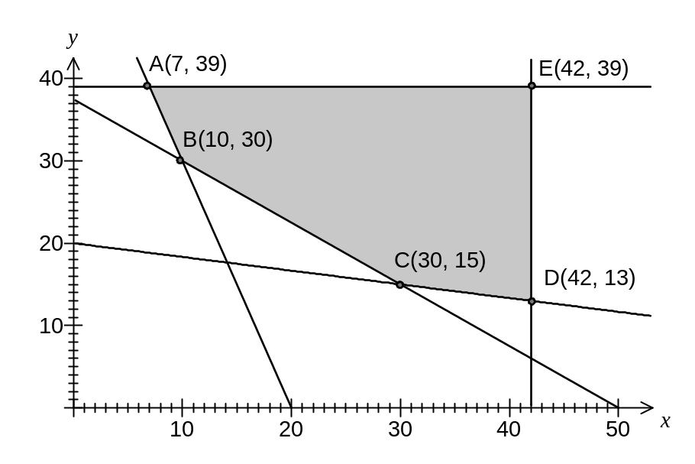
The objective function is 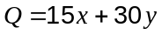.

(a) Determine the inequality satisfied by and that corresponds to the edge AB of the feasible region. (2 marks)
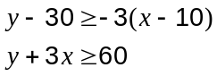

(b) Determine the maximum value of 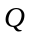 in the feasible region. (1 mark)
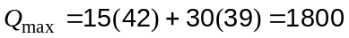

(c) Determine the minimum value of in the feasible region. (2 marks)
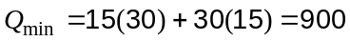

(d) The objective function is changed to 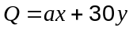.

What is the minimum possible value of the constant , given that the minimum value of still occurs at the same corner point? (3 marks)

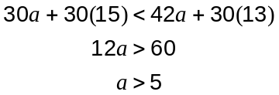

(e) An additional constraint 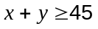 is imposed. How does this additional constraint affect the minimum value of Q in the feasible region? (2 marks)
No change in since at C(30, 15), where the minimum occurs,
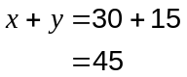
which satisfies the new constraint.

Question 17 (5 marks)
In the diagram, 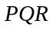 is a right-angled triangle with 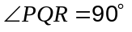 and 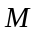 is the midpoint of 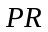. 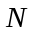 is the point where the perpendicular to at meets 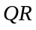.
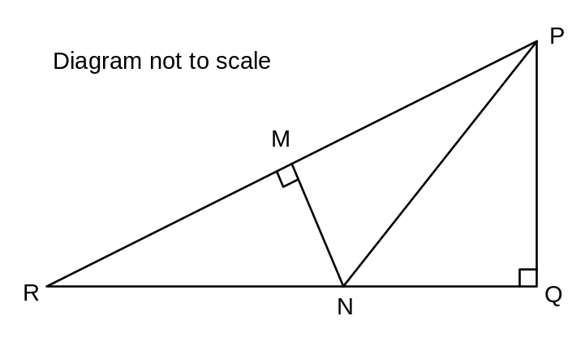

(a) Prove that . (2 marks)

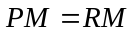 (given, M is midpoint)
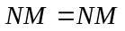 (common side)
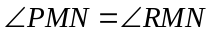 (both right-angles)
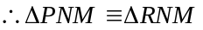 (RHS)

(b) If 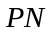 bisects 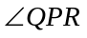, show that the ratio of the areas of 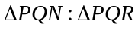 is 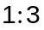. (3 marks)
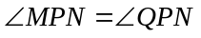 and is common side

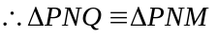 (ASA)

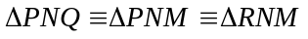 (from (a)) and so area of 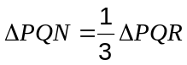, or ratio of areas
is .

Question 18 (5 marks)
A continuous random variable has probability distribution function 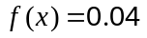, 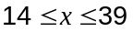.

(a) Calculate

(i) 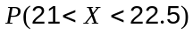. (1 mark)

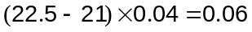

(ii) 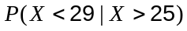. (2 marks)

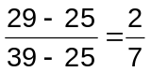

(b) If 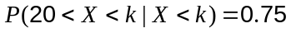, find the value of . (2 marks)
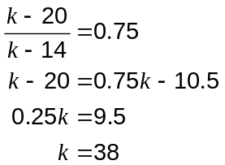

Question 19 (10 marks)
Let 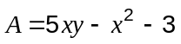 and 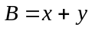, where and are integers.

(a) Evaluate and when 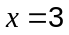 and 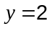. (1 mark)
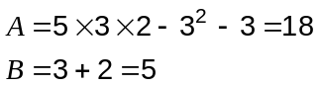

(b) The parity of an object states whether it is even or odd. Complete these tables for the parity of the product and difference of odd and even numbers.
(2 marks)

 | odd | even |  |  | odd | even
odd | odd | even |  | odd | even | odd
even | even | EVEN |  | even | ODD | EVEN

(c) Examine the parity of and for various values of and , and hence state a conjecture about the parity of when is even. (3 marks)

x | y | A | B
1 | 2 | 8 | 3
1 | 3 | 13 | 4
1 | 4 | 18 | 5
2 | 2 | 15 | 4
2 | 3 | 25 | 5
2 | 4 | 35 | 6
3 | 2 | 20 | 5
3 | 3 | 35 | 6
3 | 4 | 50 | 7

When A is even, B is always odd.

(d) Prove the conjecture in (c). (4 marks)

If 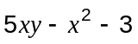 is even, then since 3 is odd, 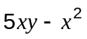 must also be odd.

If 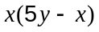 is odd, then both and 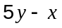 must be odd.

Hence is odd.

If is odd, but is odd, then 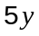 must be even.

Since 5 is odd, then must be even.

Since is odd and is even then , will always be odd.

Question 20 (9 marks)
(a) A function is such that 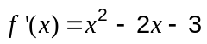.

(i) State the -coordinate of the minimum of . (2 marks)
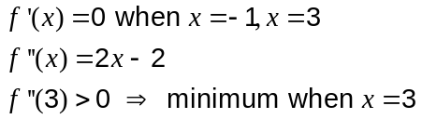

(ii) Justify that has a point of inflection when 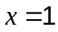. (2 marks)

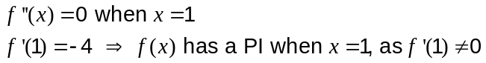

(iii) Find 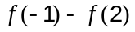. (2 marks)
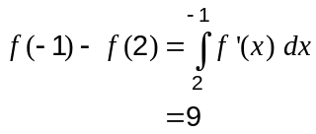

(b) A function 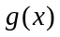 has the properties 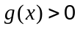, 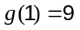 and 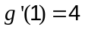.

If 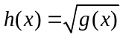, find 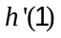. (3 marks)
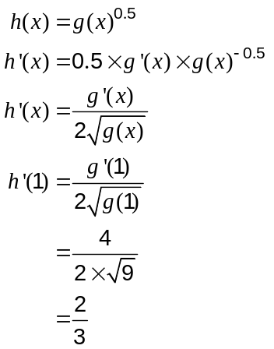

Additional working space

Question number: _________

This examination paper may be freely copied, or communicated on an intranet, for non-commercial purposes within educational institutes that have purchased the paper from WA Examination Papers provided that WA Examination Papers is acknowledged as the copyright owner. Teachers within purchasing schools may change the paper provided that WA Examination Paper's moral rights are not infringed.

Copying or communication for any other purposes can only be done within the terms of the Copyright Act or with prior written permission of WA Examination papers.

Published by WA Examination Papers
PO Box 445 Claremont WA 6910

